Experiment-21
Aim:
To write a Prolog program to implement the Towers of Hanoi problem using recursion.
Algorithm:
- Start the program.
- If the number of disks is 1, move the disk directly from the source rod to the destination rod.
- Otherwise, move \(N-1\) disks from the source rod to the auxiliary rod.
- Move the largest disk from the source rod to the destination rod.
- Move the remaining \(N-1\) disks from the auxiliary rod to the destination rod.
- Repeat recursively until all disks are moved.
- Stop the program.
Code:
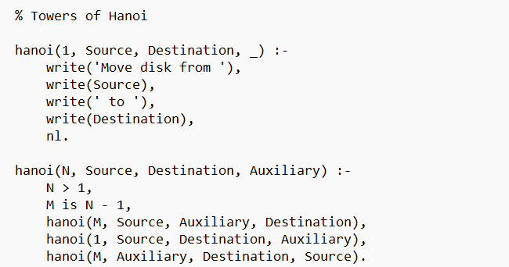
Output:
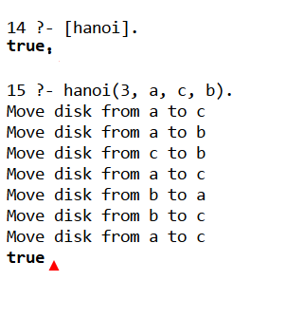
Result: Thus the Prolog prog to implement the Towers of Hanoi problem using recursion

